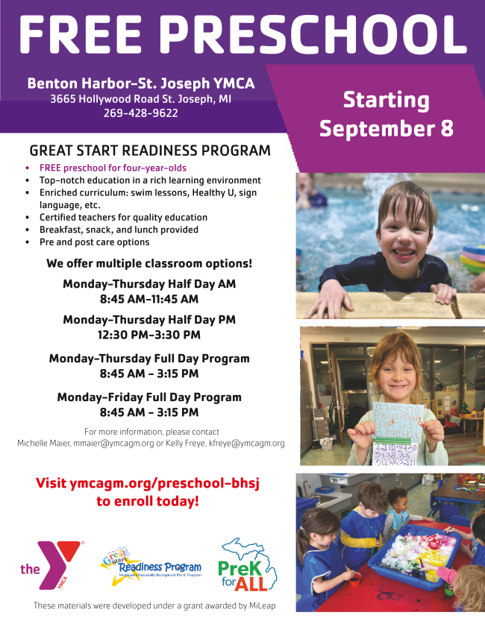

The YMCA of Greater Michiana is opening registration for its 2026 Preschool programs at locations in Benton Harbor–St. Joseph and Niles-Buchanan, offering families across Southwest Michigan high-quality early learning options in licensed, supportive environments led by experienced educators.

Designed to support working families while providing children with a safe, engaging, and fun environment, YMCA programs focus on learning, confidence-building, physical activity, and social connection—all grounded in the Y’s mission to nurture the potential of every child.

The YMCA of Greater Michiana offers two distinct preschool pathways at Benton Harbor-St. Joseph YMCA & Northside Child Development Center (Niles):

Great Start Readiness Program (GSRP) — A FREE, state-funded preschool program for eligible four-year-olds offered at select YMCA locations.*

Tuition-based preschool programs — Serving children ages 2.5 to 4, with flexible scheduling options for families seeking high-quality early childhood education. Tuition-based preschool programs start at approximately $190 per month for YMCA members, with community rates beginning around $255 per month. Financial assistance is available to ensure cost is never a barrier for families seeking early learning opportunities.

“Early learning plays a critical role in a child’s development,” said Michelle Skalla, YMCA Director, Great Start Readiness Program, and Northside Child Development Center. “Our preschool programs provide children with a strong foundation for learning while supporting families with trusted, high-quality care.”

Also available through the YMCA of Greater Michiana: Summer Day Camp and youth programs are offered across multiple YMCA locations in Southwest Michigan and Northern Indiana, providing families with trusted care and enrichment year-round. For full program details, registration timelines, and updates, visit www.ymcagm.org or call (269) 683-1552.

*Michigan’s Great Start Readiness Program (GSRP), a state-funded preschool option offered at select YMCA of Greater Michiana locations, serves eligible Michigan four-year-olds. Enrollment priority and cost structure are based on Michigan eligibility guidelines.

FOLLOW YMCA OF GREATER MICHIANA ON SOCIAL MEDIA



